**Web Application Deployed via Jenkins**

**Practice Project**

**Aim:**

Create a sample web application in .NET and configure it to be deployed via Jenkins.

**GitHub link:**

**Procedure:**

* Create three class Library BAL(Business Access Logic layer),DAL,Helper classes.
* BAL class has the properties of the class and their validations
* DAL class has the logic to access the data from the database
* Helper class is used as an extra layer over DAL to hide the details of the logic.
* Add Business Reference to DAL and Helper.
* Add DAL reference to Helper.
* Add Helper reference to Application.
* Build the solution and set the dependencies.
* MVC depends on BAL and Helper
* Data Acccess Library depends on BLL
* Helper depends on BLL and DAL
* Create a model Pizza1
* Create a controller class pizzaController
* Create views for Create,delete,details,Edit and list
* And run all
* After the Application runs push it to GitHub repository
* Open Jenkins and create an application -> free style and save
* Go to configure and go to Github repository and paste the Github link

**Output:**

**Home Page:**

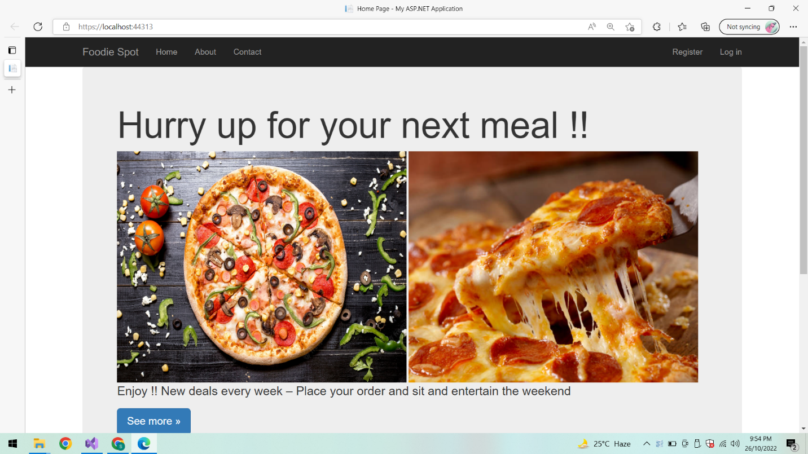

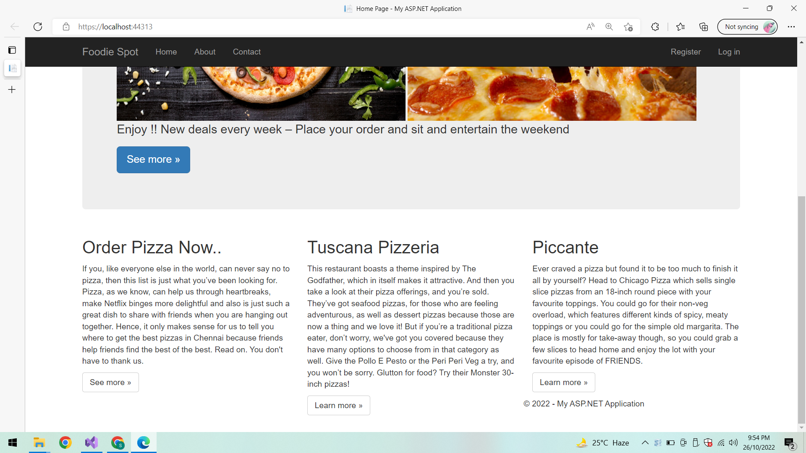

**Contact:**

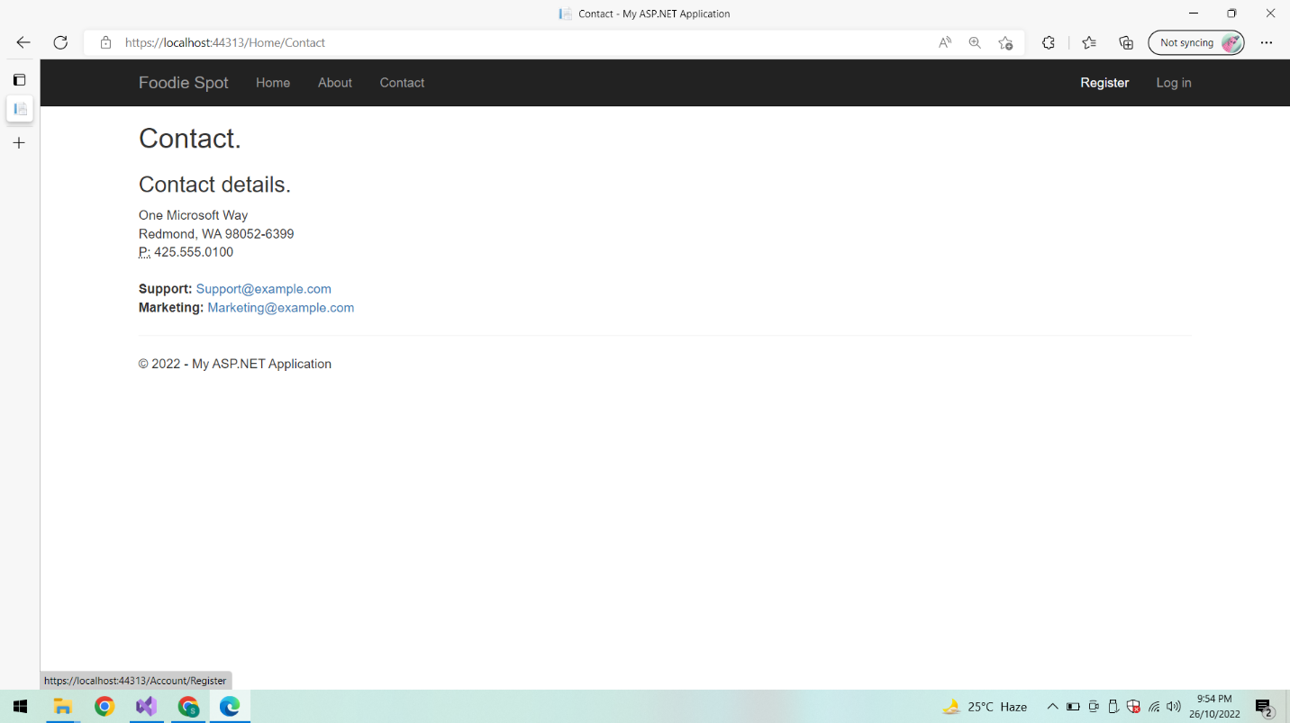

**About:**

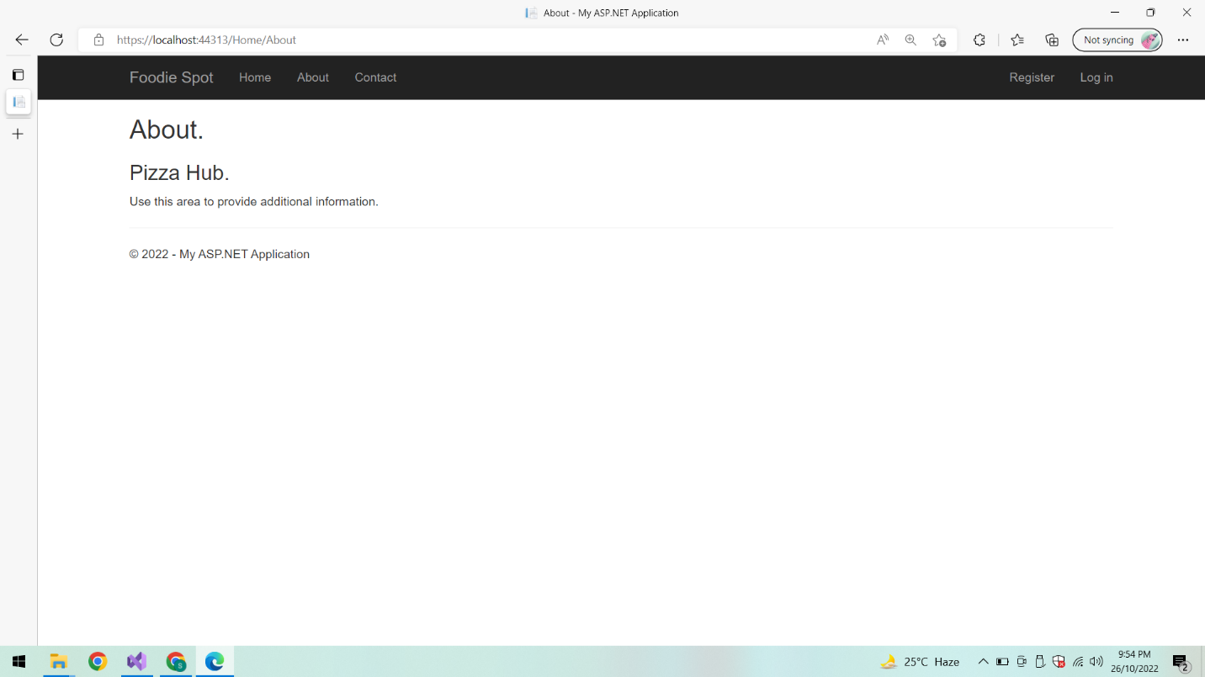

**Registration:**

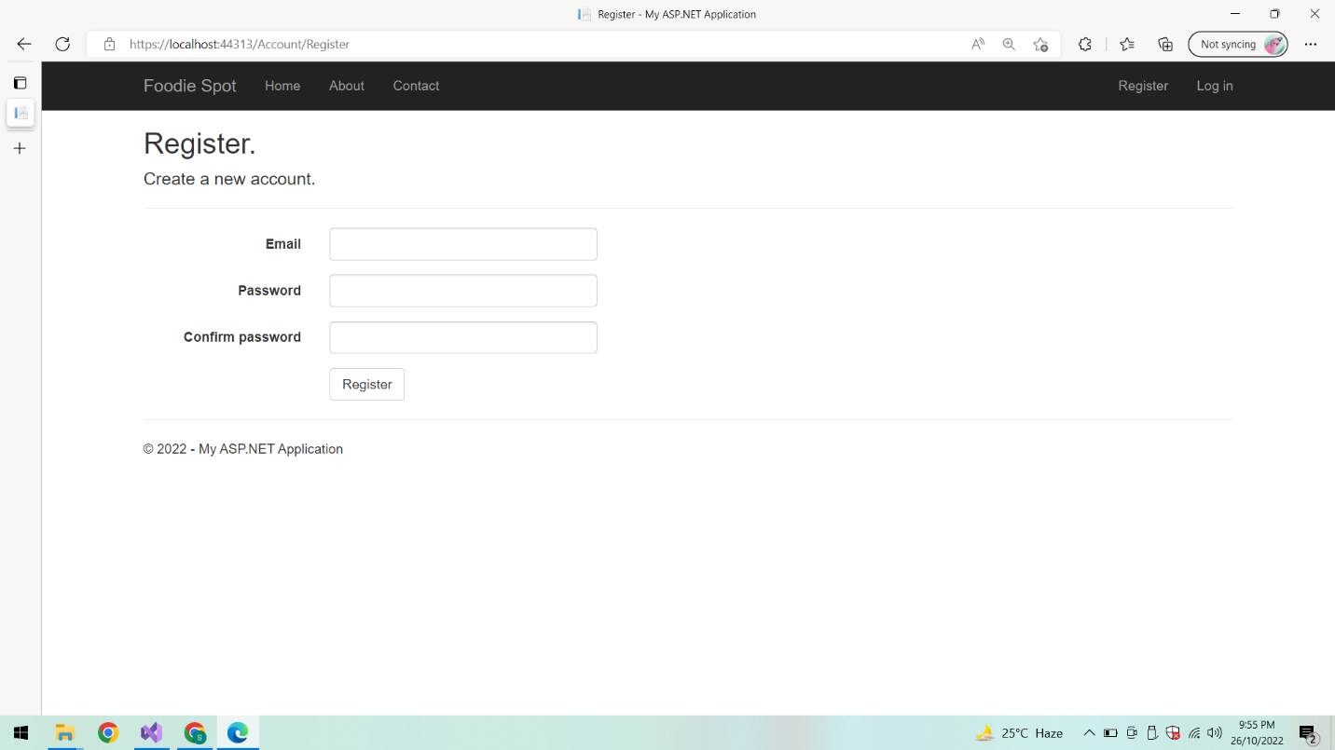

**Validations:**

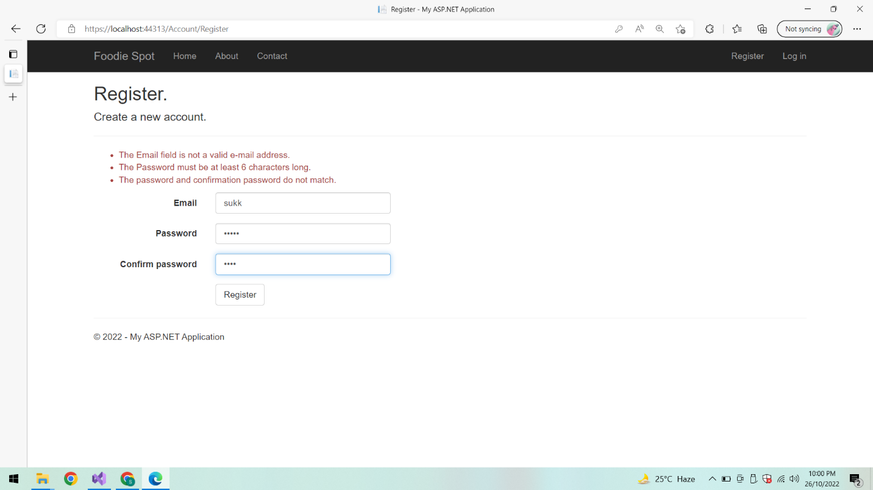

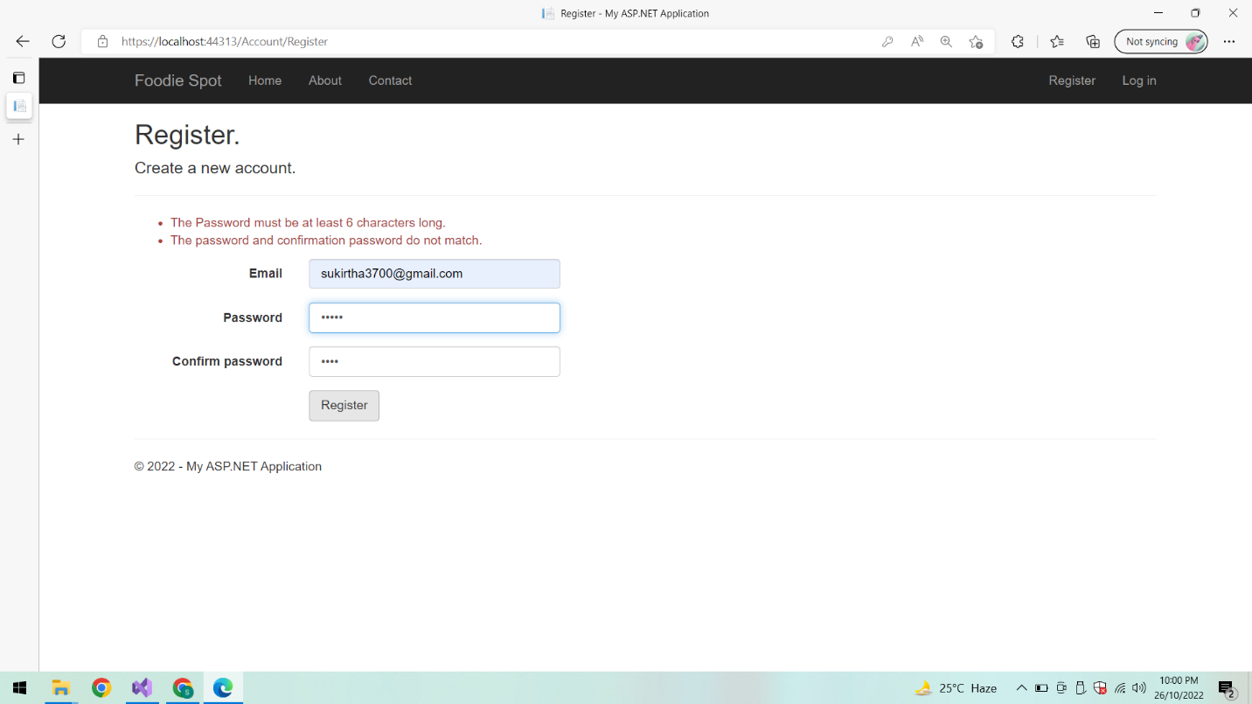

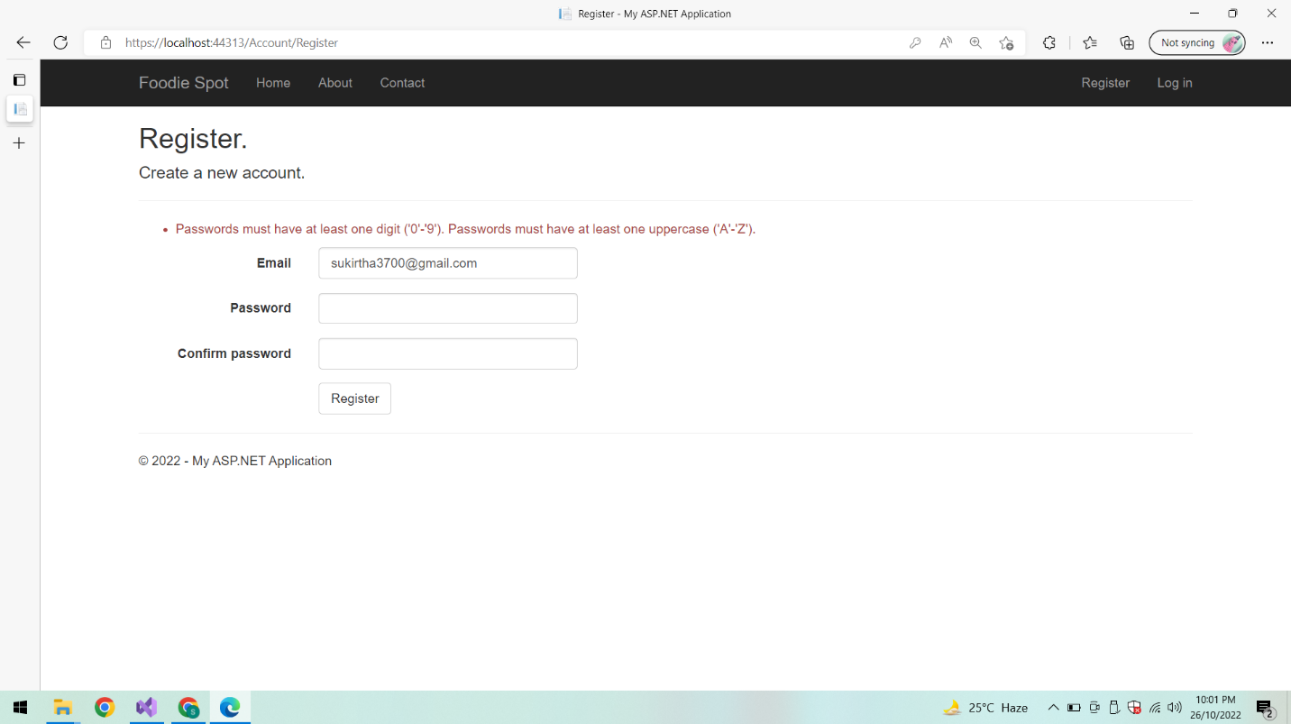

**On successful Registration:**

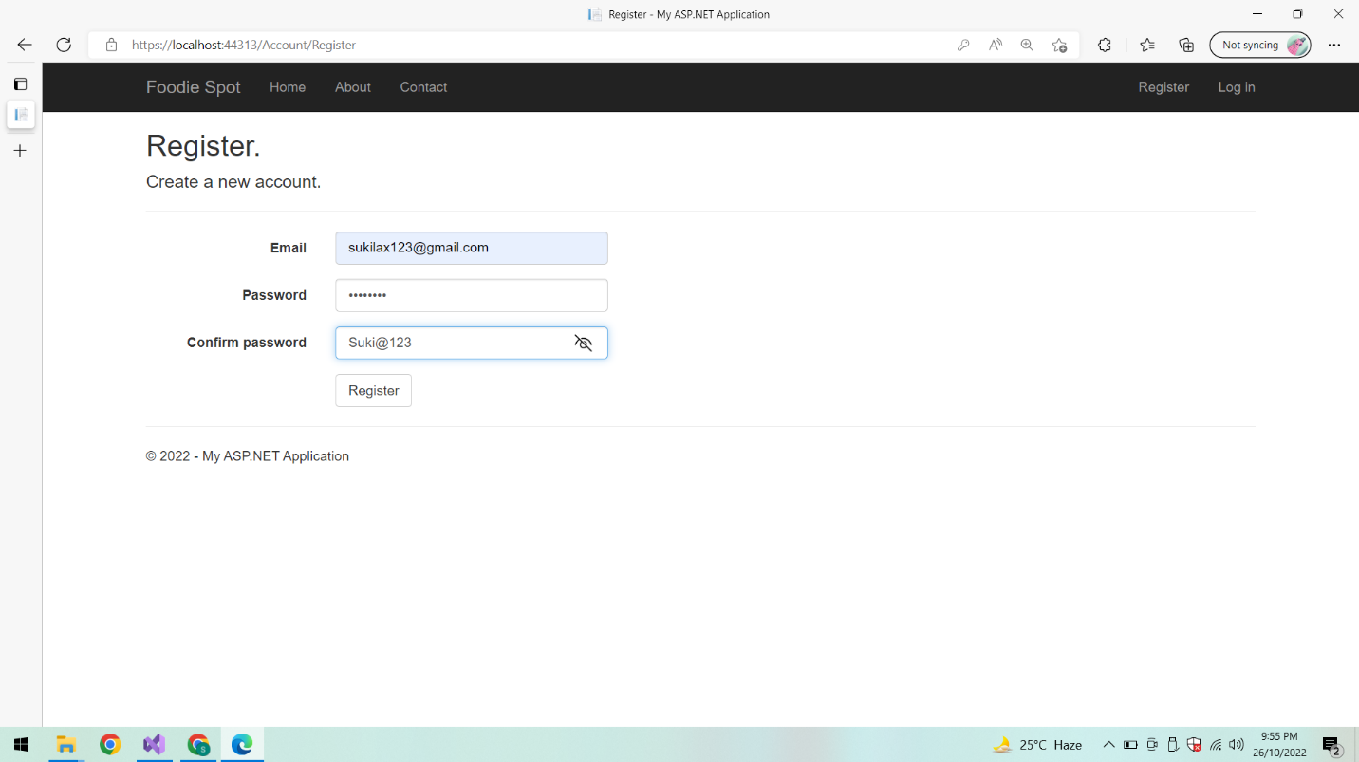

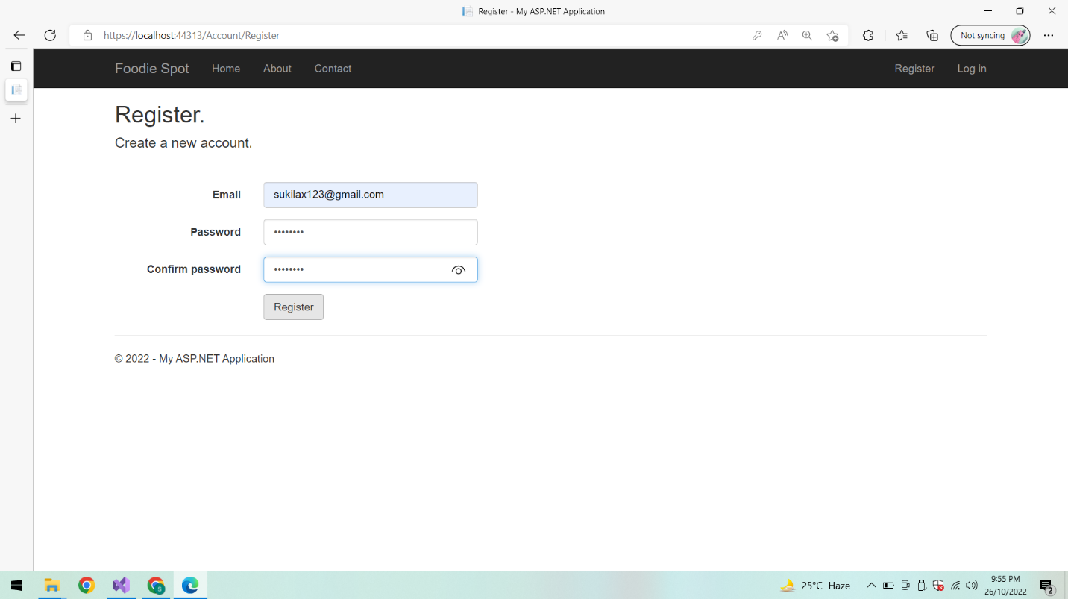

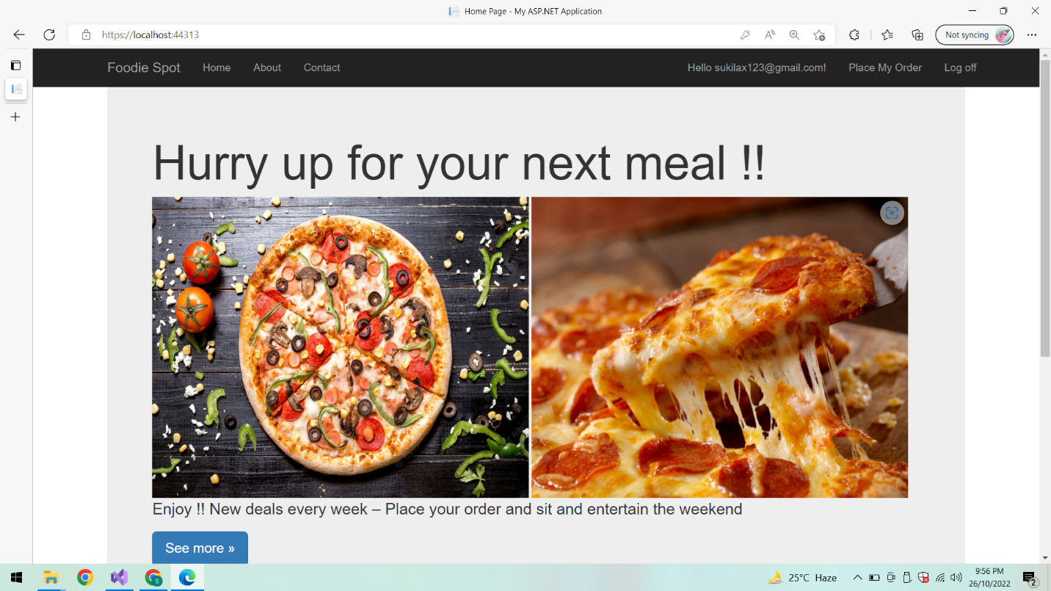

**Log off:**



**Login :**

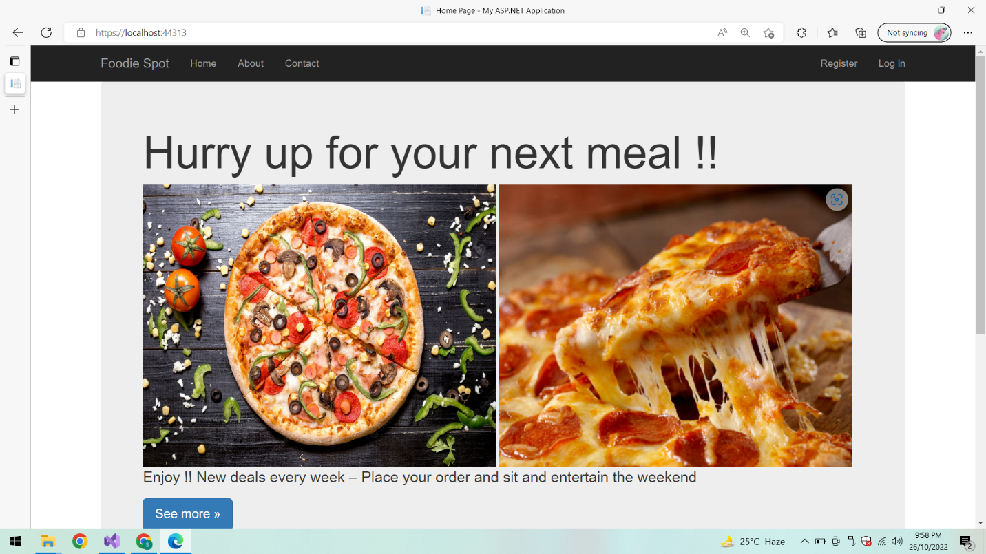

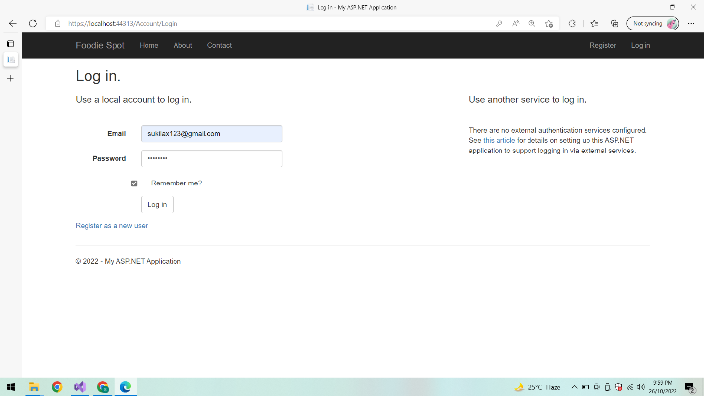

**On successful Login:**

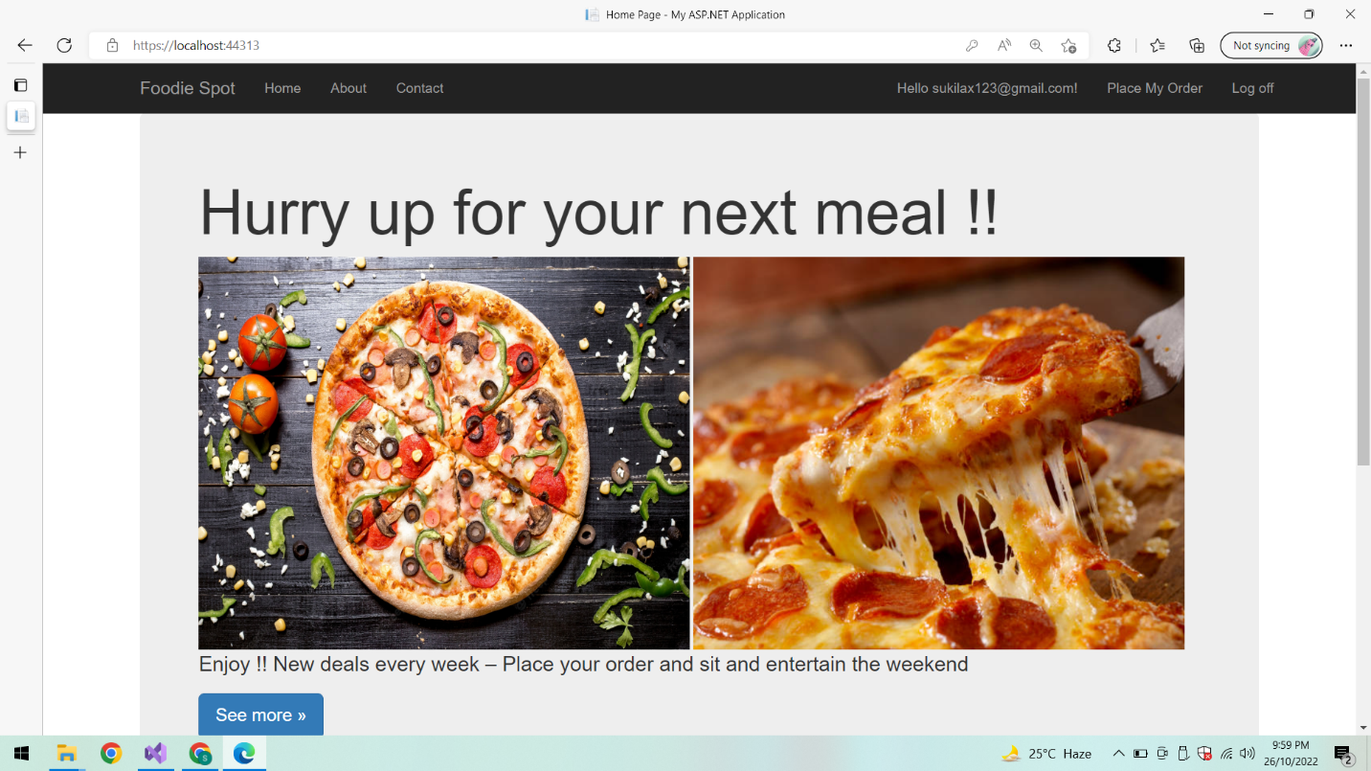

**Place my order:**

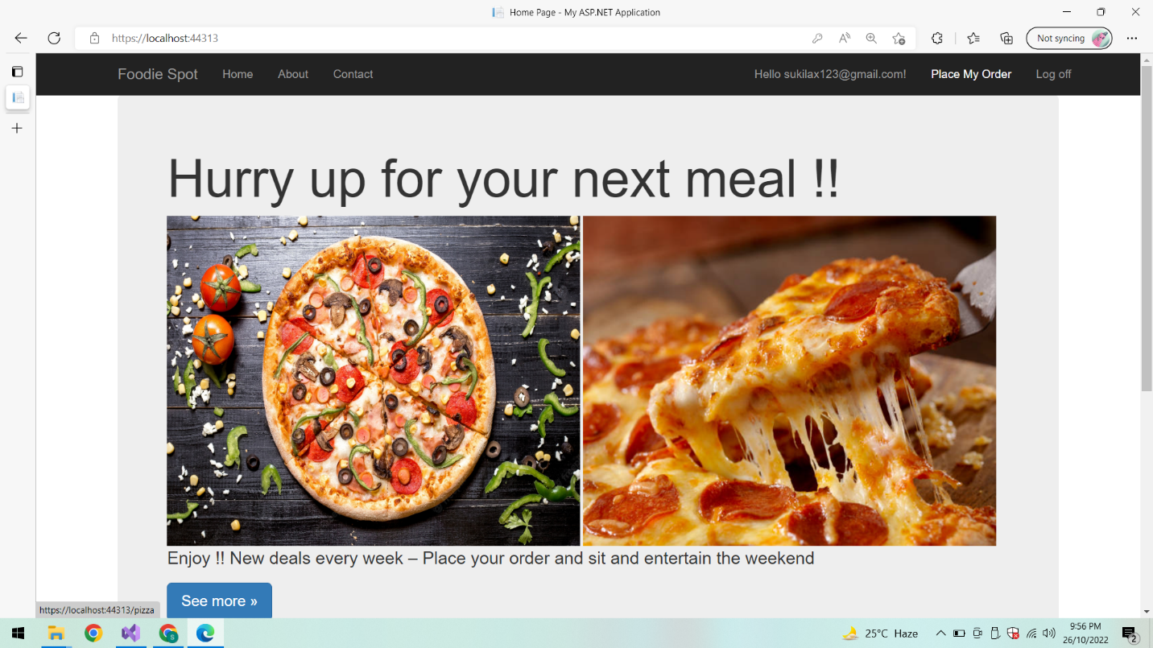

**Place order:**

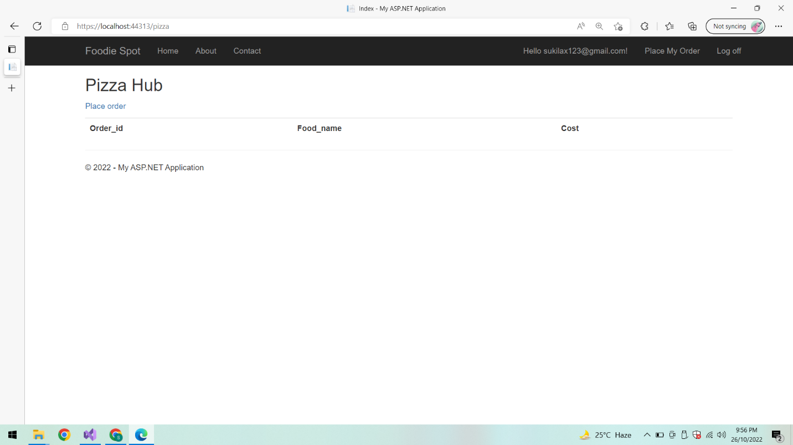

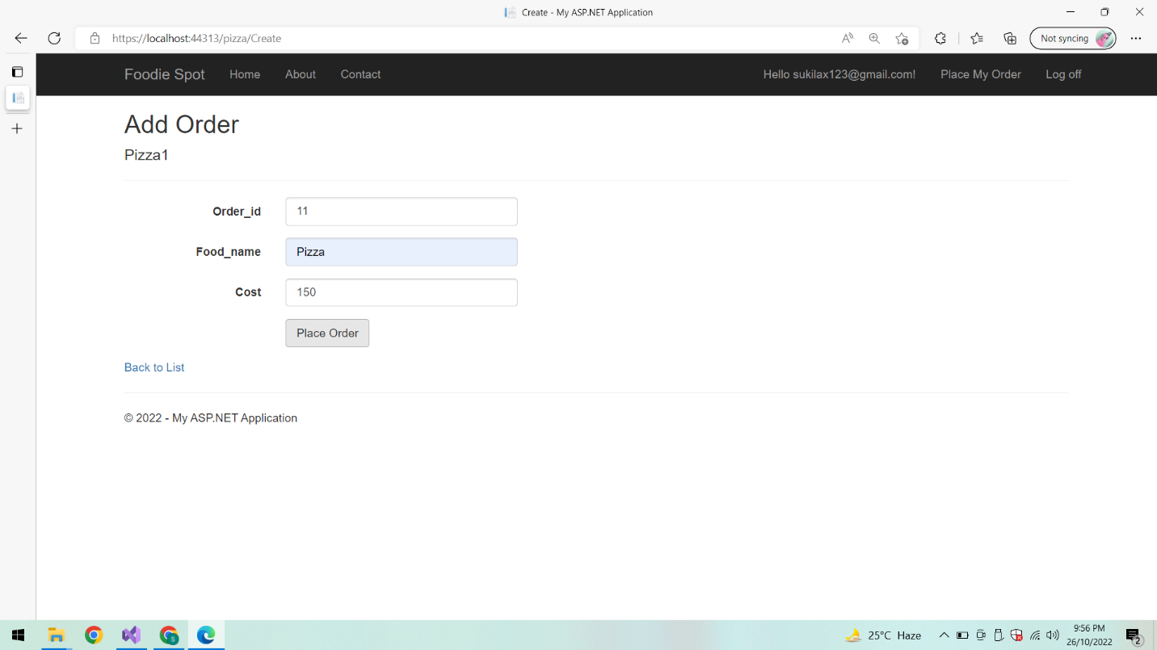

**After adding an order list of order is displayed:**

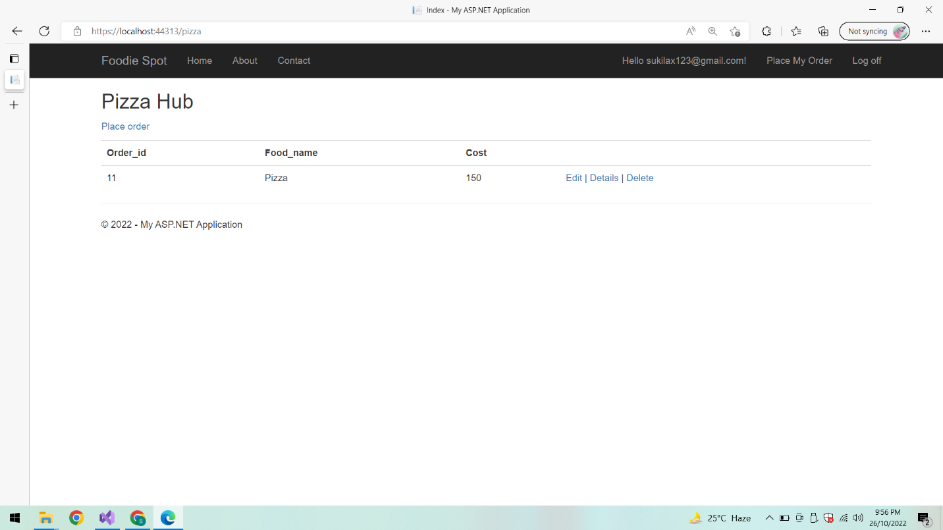

**On clicking Edit to Update my order details:**

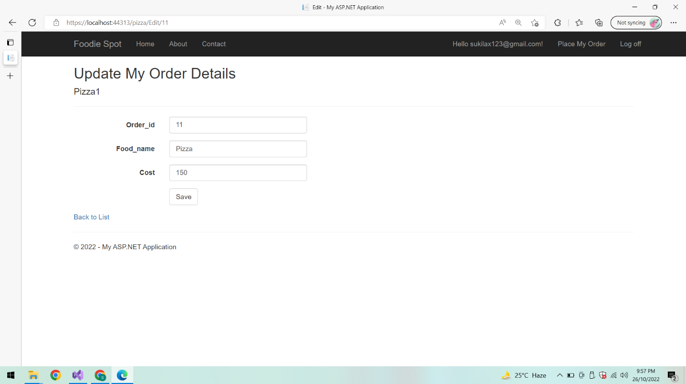

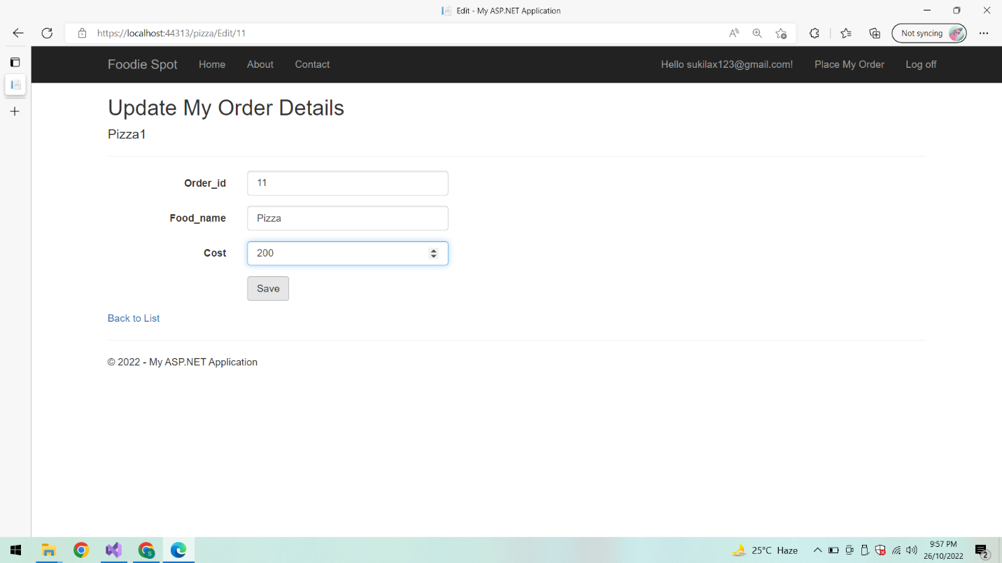

**After updating the order details:**

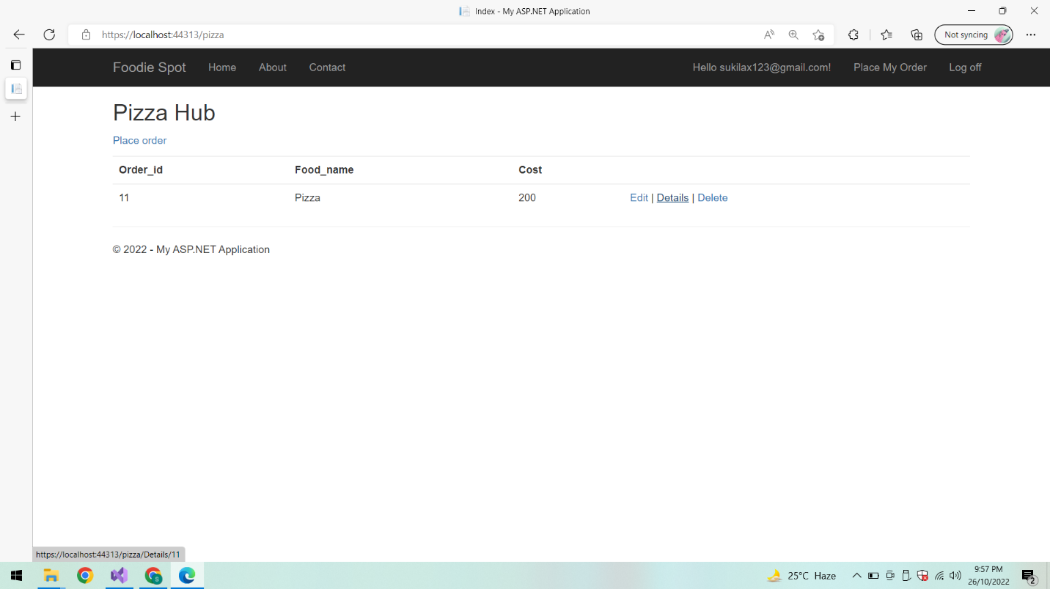

**Order History:**

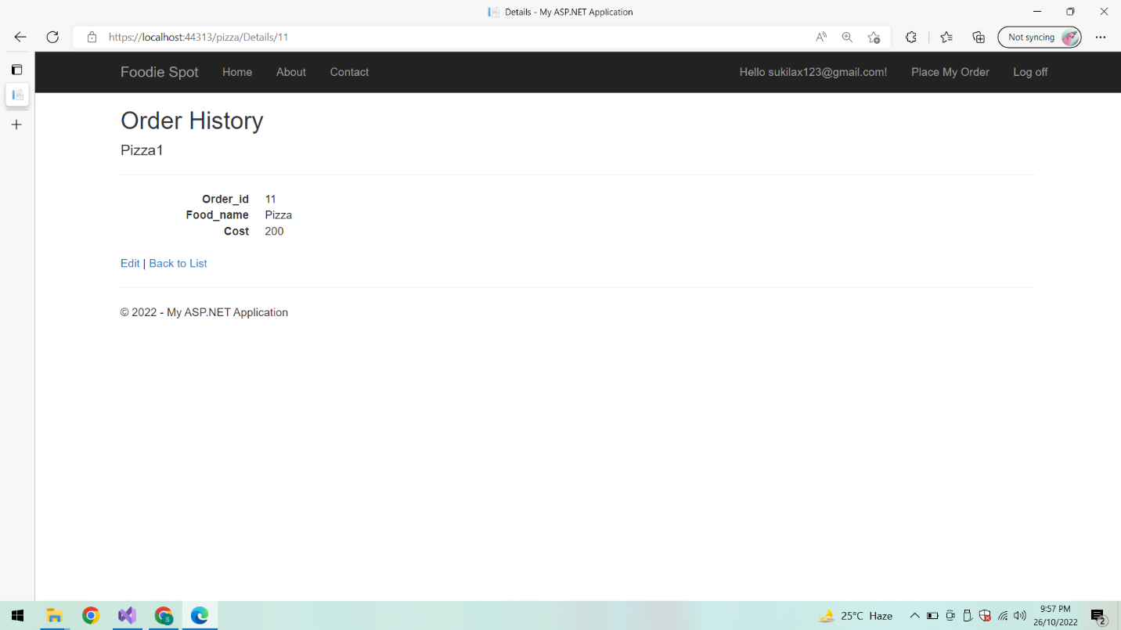

**On clicking Edit to update order details:**

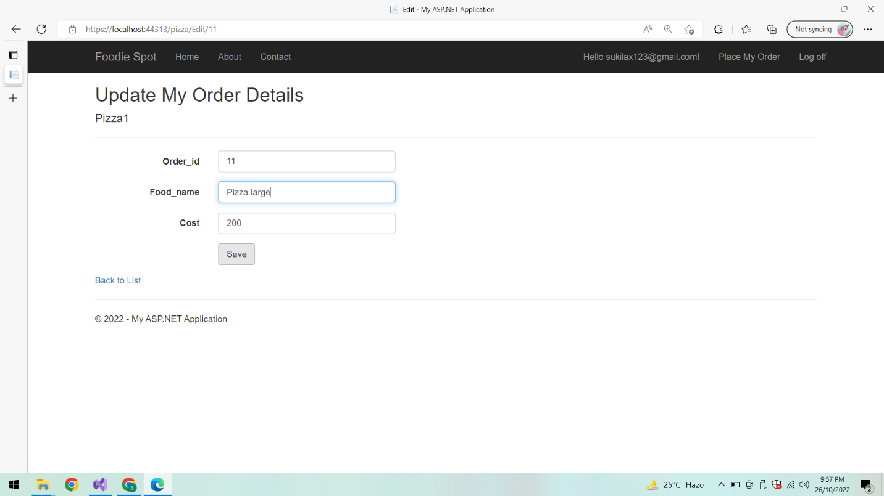

**After updation list of Order details is displayed:**

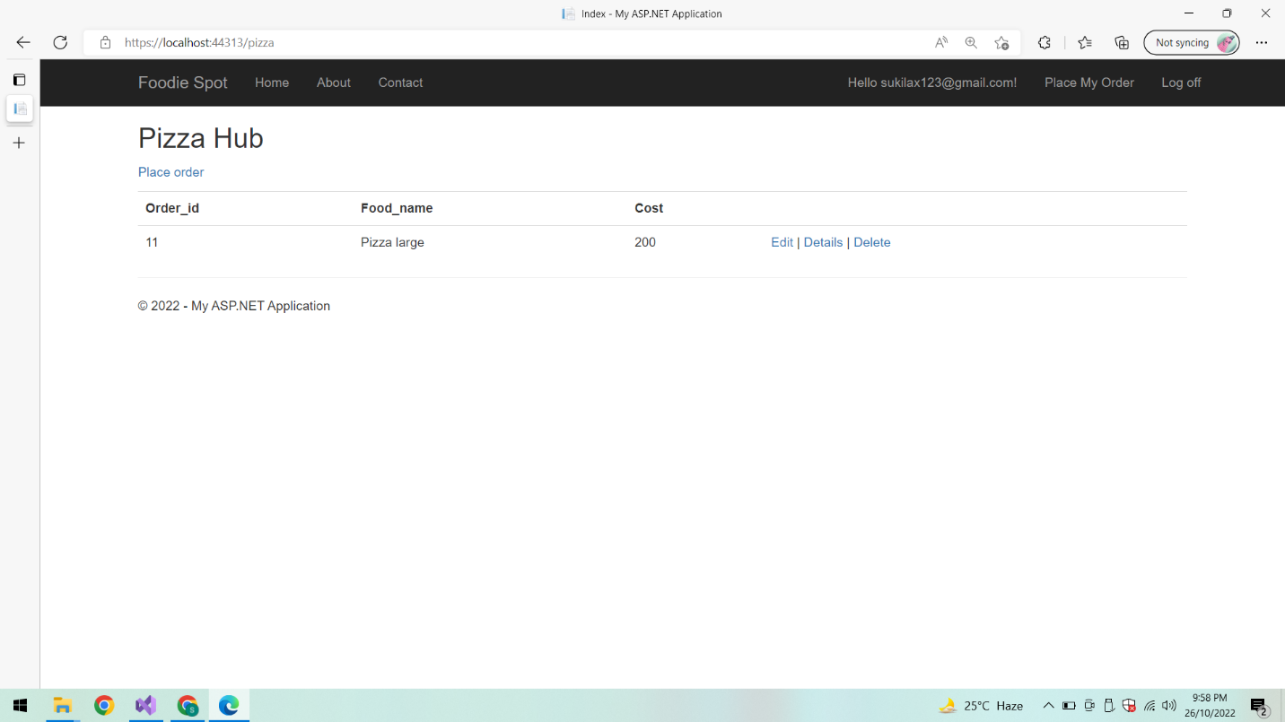

**Delete order:**

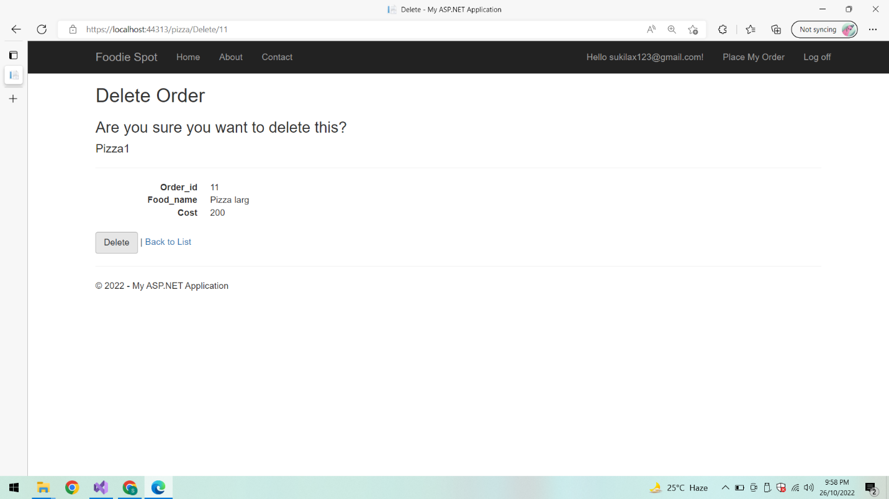

**After deletion:**

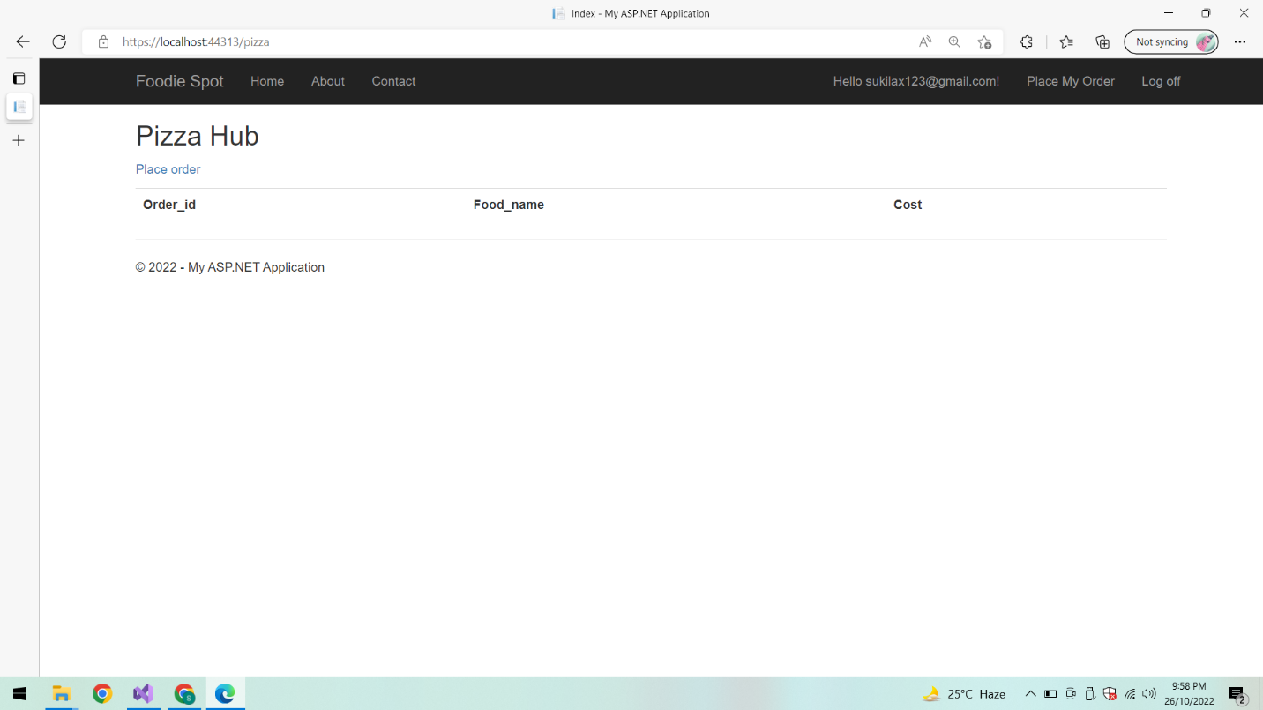

**Log off:**

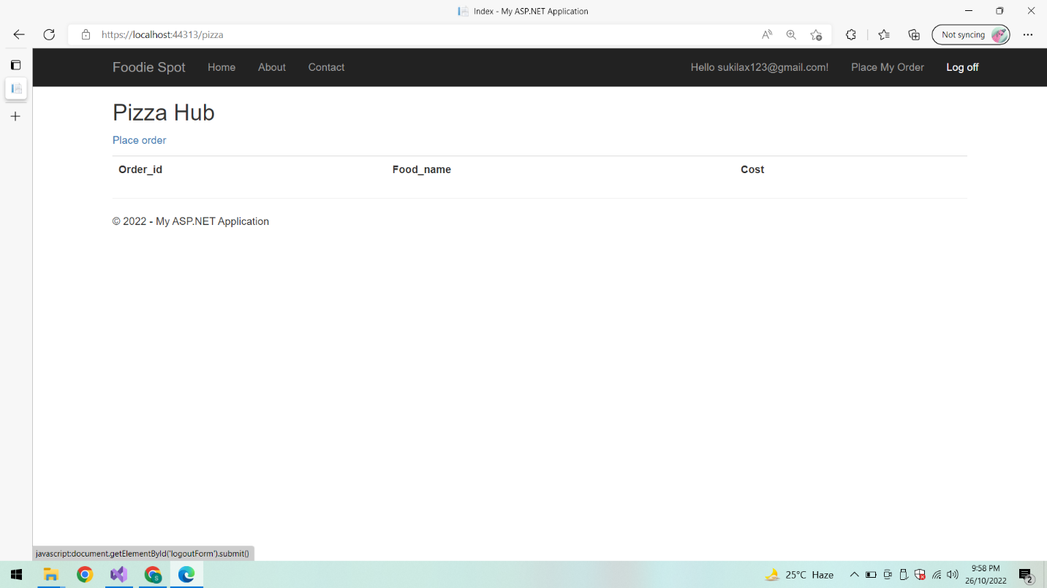

**Redirects to Home Page:**



**Jenkins:**

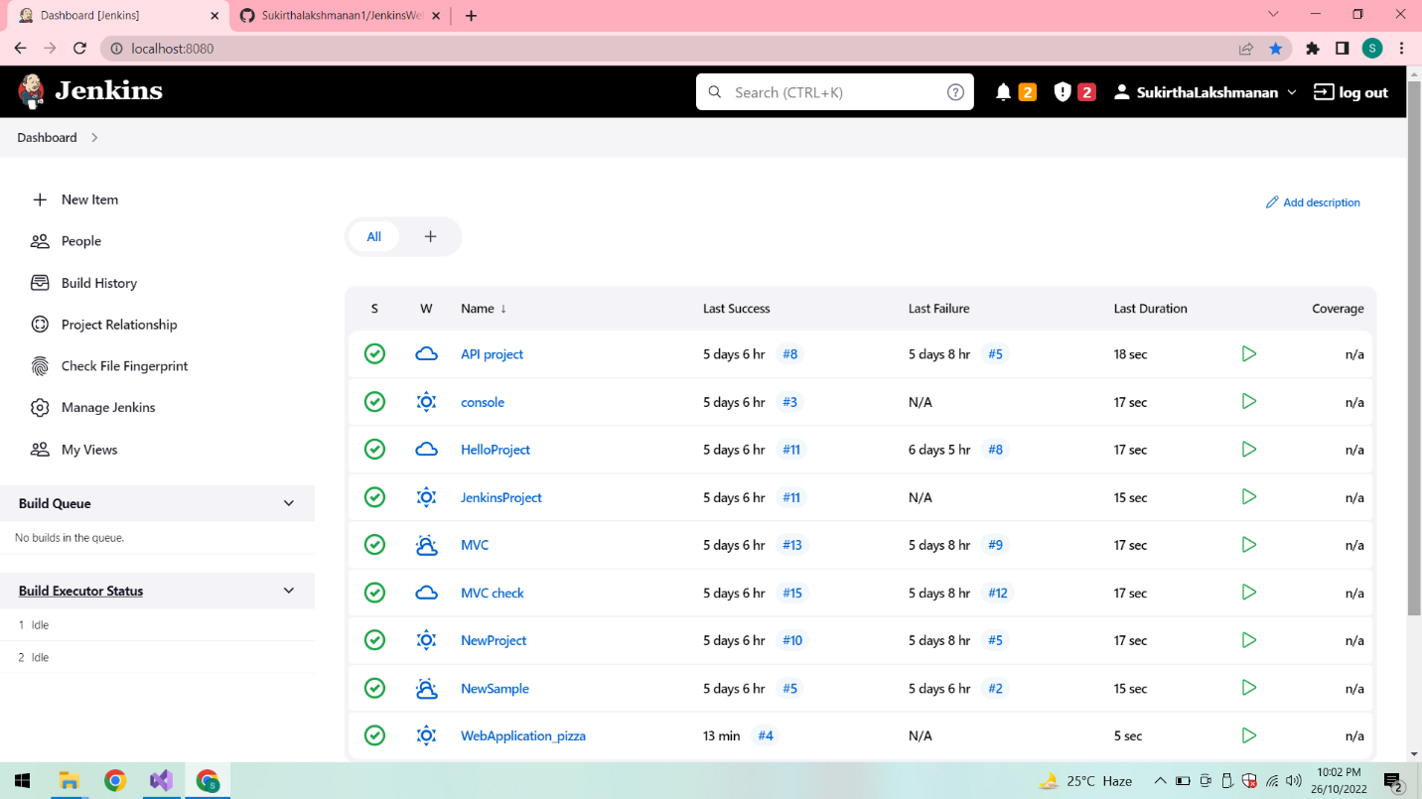

**After Successful Build:**

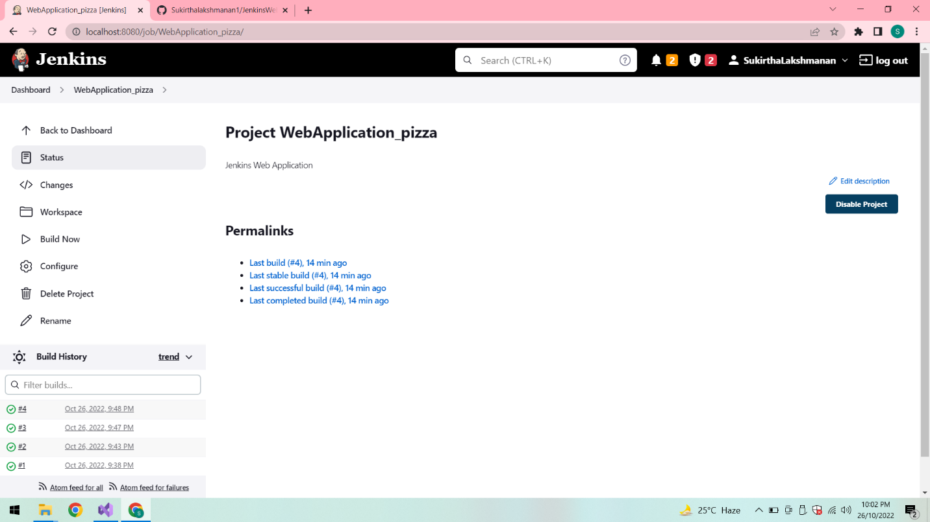

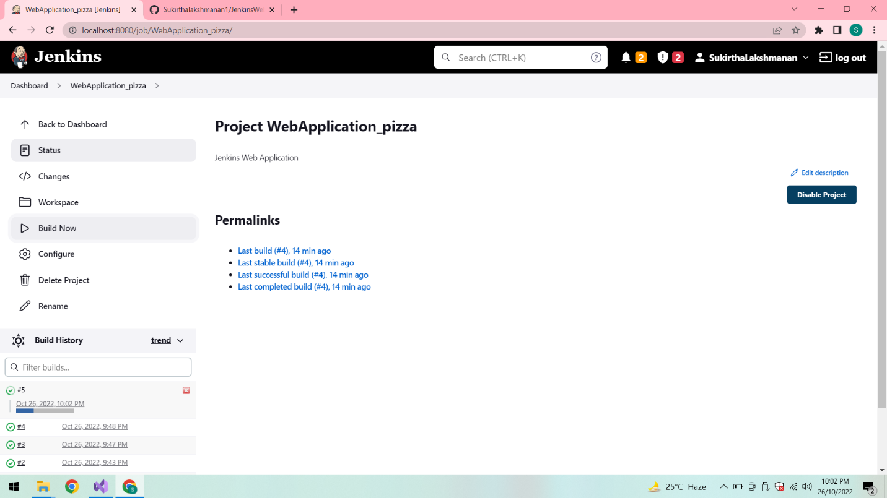

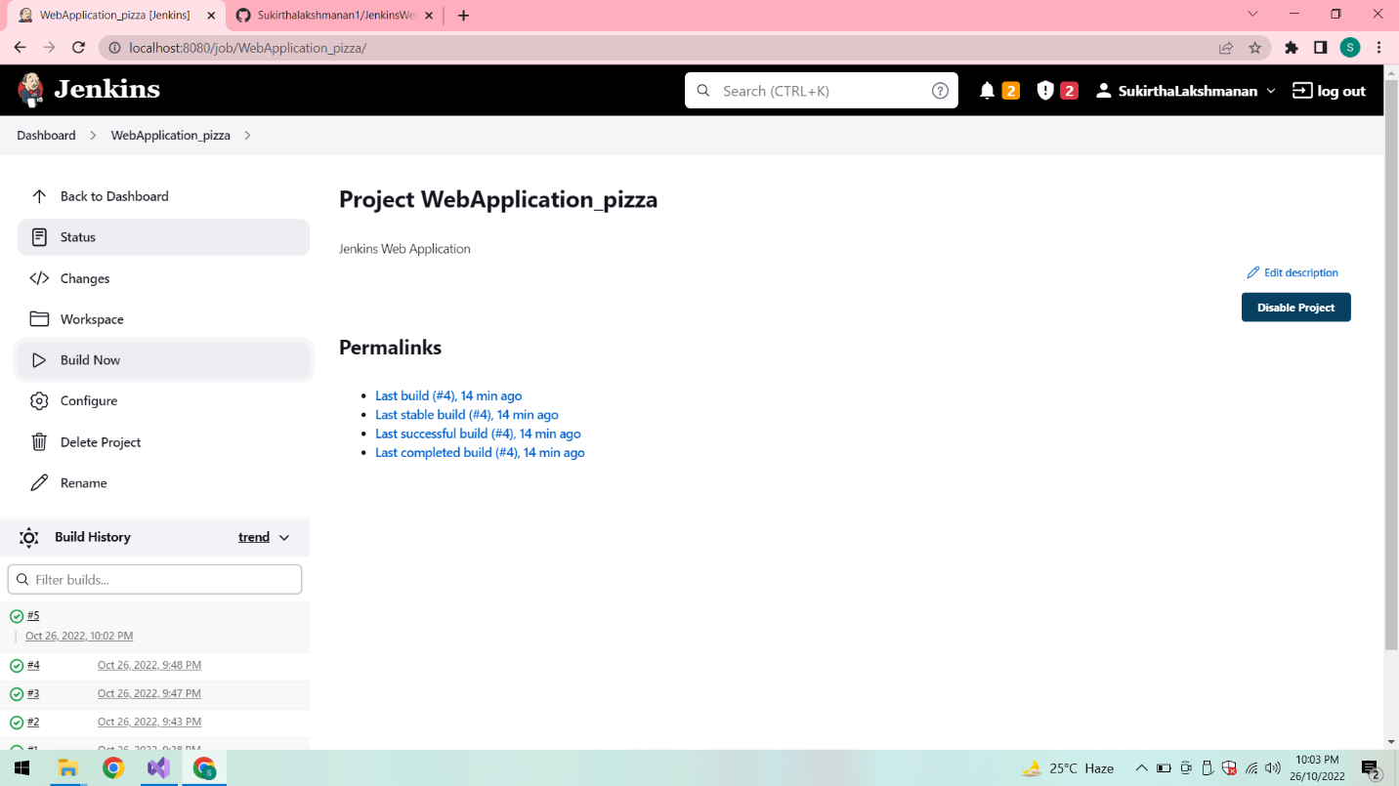

**Console Output:**

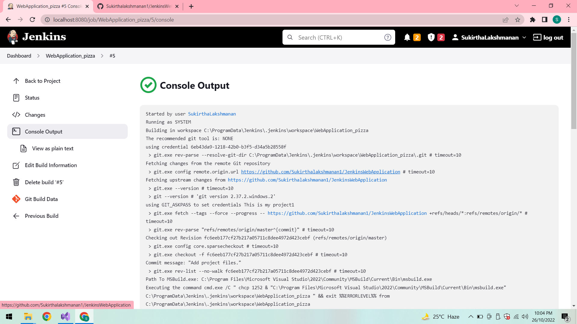

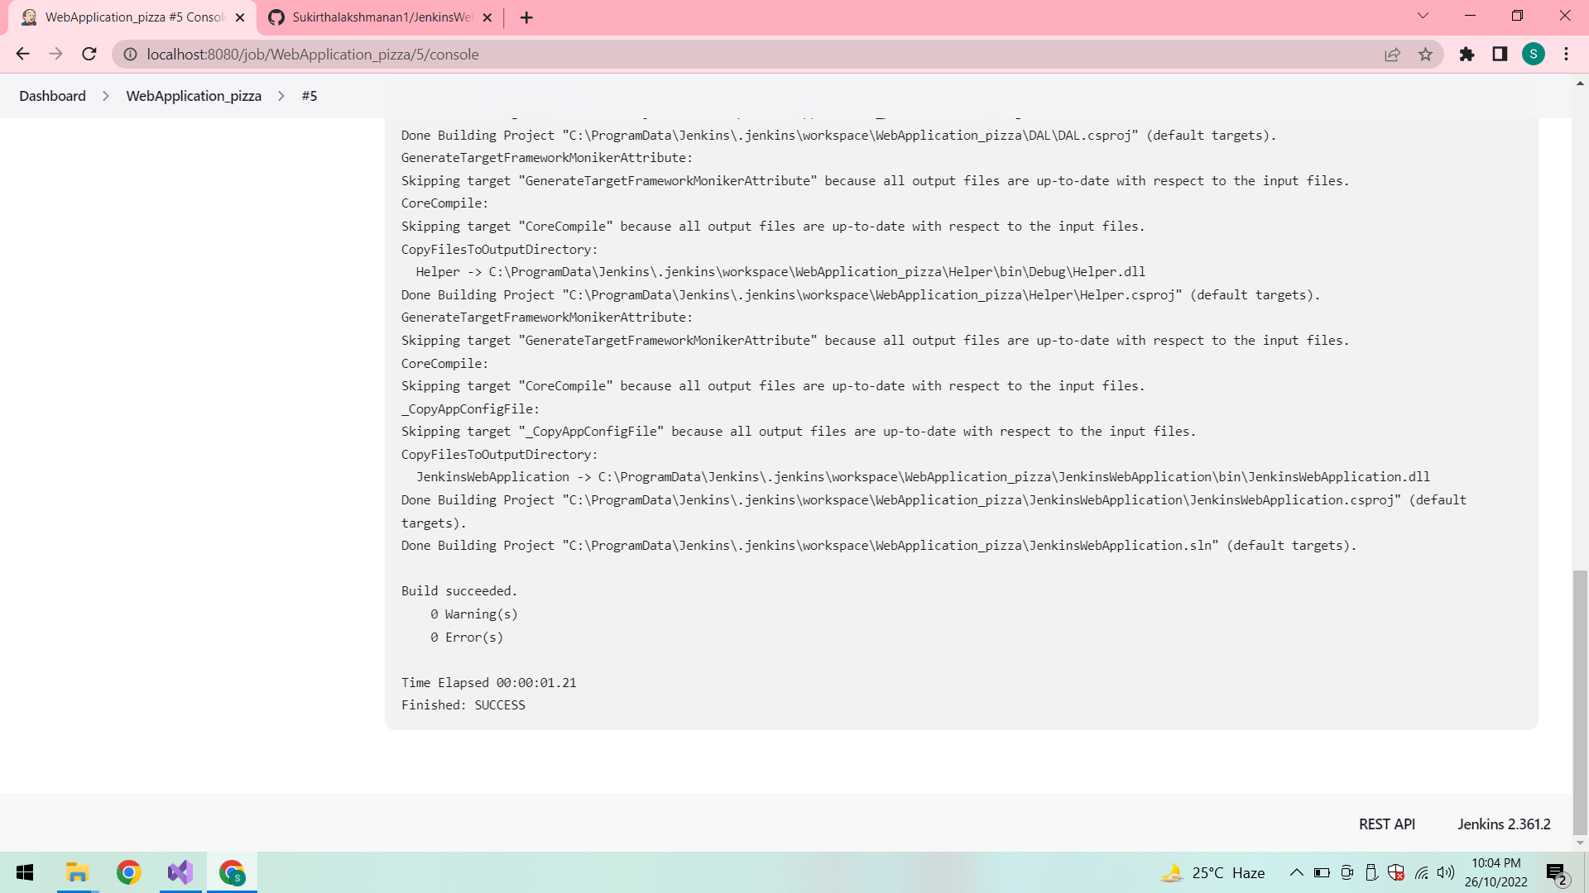

**Build Triggers:**

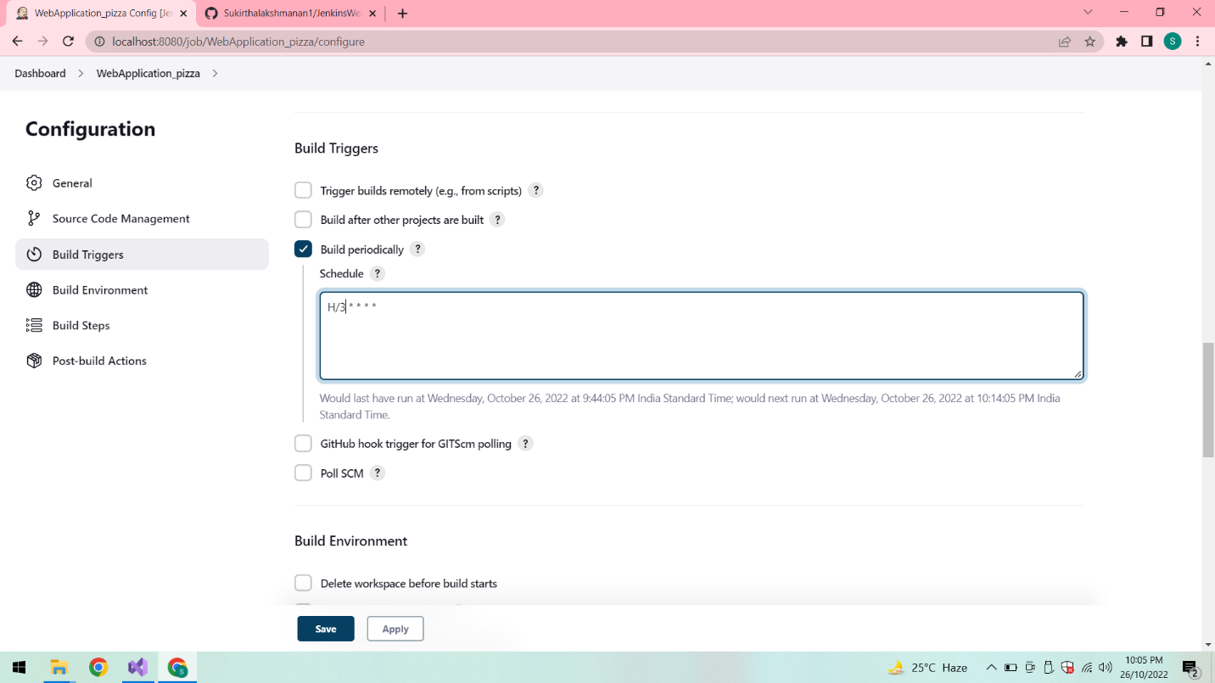

**Workspace:**

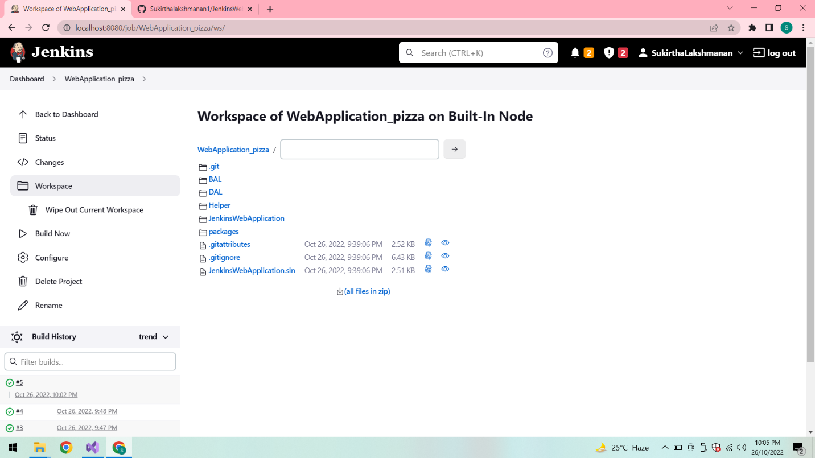

**Automatic Build:**

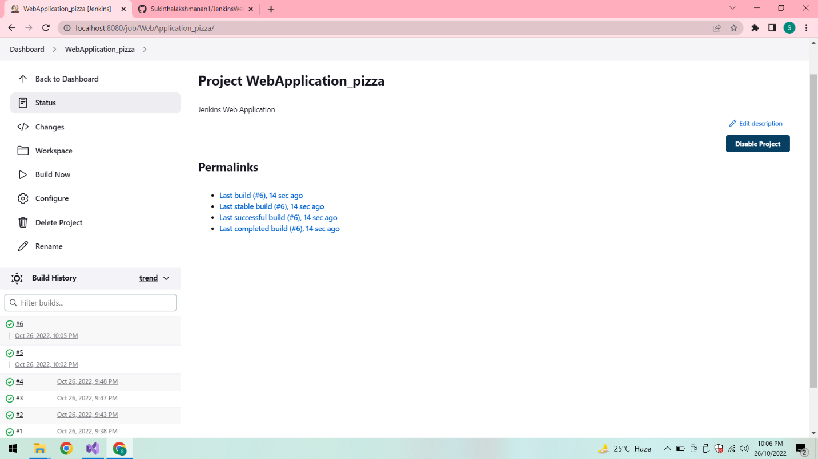

**Conclusion:**

Thus the web application is created successfully and deployed it via Jenkins.